**EX.NO:5**

**DATE:**

**CREATING VIEWS**

After the completion of this exercise, students will be able to do the following:

● Describe a view

● Create, alter the definition of, and drop a view

● Retrieve data through a view

● Insert, update, and delete data through a view

● Create and use an inline view

**View:**

A view is a logical table based on a table or another view. A view contains no data but is like a

window through which data from tables can be viewed or changed.The tables on which a view is

based are called base tables.

**Advantages of Views:**

● To restrict data access

● To make complex queries easy

● To provide data independence

● To present different views of the same data

**Classification of views:**

1. Simple view

2. Complex view

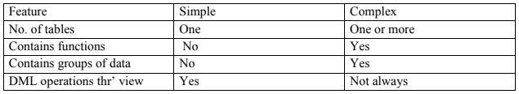

CREATE OR REPLACE FORCE/NOFORCE VIEW view_name AS Subquery WITH CHECK

OPTION CONSTRAINT constraint WITH READ ONLY CONSTRAINT constraint;

FORCE - Creates the view regardless of whether or not the base tables exist.

NOFORCE - Creates the view only if the ase table exist.

WITH CHECK OPTION CONSTRAINT-specifies that only rows accessible to the view can be

inserted or updated.

WITH READ ONLY CONSTRAINT-ensures that no DML operations can be performed on the

View.

**Example: 1** (Without using Column aliases)

Create a view EMPVU80 that contains details of employees in department80.

**Example 2:**

CREATE VIEW empvu80 AS SELECT employee_id, last_name, salary FROM employees

WHERE department_id=80;

**Example:1** (Using column aliases)

CREATE VIEW salvu50

AS SELECT employee_id,id_number, last_name NAME, salary *12 ANN_SALARY

FROM employees

WHERE department_id=50;

Retrieving data from a view

Example:

SELECT * from salvu50;

Modifying a view

A view can be altered without dropping, re-creating.

Example: (Simple view)

Modify the EMPVU80 view by using CREATE OR REPLACE.

CREATE OR REPLACE VIEW empvu80 (id_number, name, sal, department_id)

AS SELECT employee_id,first_name, last_name, salary, department_id

FROM employees

WHERE department_id=80;

**Example:** (complex view)

CREATE VIEW dept_sum_vu (name, minsal, maxsal,avgsal)

AS SELECT d.department_name, MIN(e.salary), MAX(e.salary), AVG(e.salary)

FROM employees e, department d

WHERE e.deparment_id=d.deparment_id

GROUP BY d.department_name;

**Rules for performing DML operations on view**

* Can perform operations on simple views
* Cannot remove a row if the view contains the following:
* Group functions
* Group By clause
* Distinct keyword
* Cannot modify data in a view if it contains
* Group functions
* Group By clause
* Distinct keyword
* Columns contain by expressions
* Cannot add data thr‘ a view if it contains
* Group functions
* Group By clause
* Distinct keyword
* Columns contain by expressions
* NOT NULL columns in the base table that are not selected by the view

**Example:** (Using the WITH CHECK OPTION clause)

CREATE OR REPLACE VIEW empvu20

AS SELECT *

FROM employees

WHERE department_id=20

WITH CHECK OPTION CONSTRAINT empvu20_ck;

Note:Any attempt to change the department number for any row in the view fails because it

violates the WITH CHECK OPTION constraint.

**Example** – (Execute this and note the error)

UPDATE empvu20 SET department_id=10 WHERE employee_id=201;

**Denying DML operations**

**Use of the WITH READ ONLY option.**

Any attempt to perform a DML on any row in the view results in an oracle server error.

Try this code:

CREATE OR REPLACE VIEW empvu10(employee_number, employee_name,job_title)

AS SELECT employee_id, last_name, job_id

FROM employees

WHERE department_id=10

WITH READ ONLY;

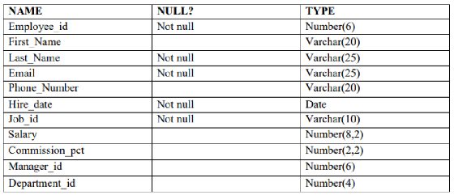

CREATE TABLE Employee (

Employee_id NUMBER(6) NOT NULL,

First_Name VARCHAR2(20),

Last_Name VARCHAR2(25) NOT NULL,

Email VARCHAR2(25) NOT NULL,

Phone_Number VARCHAR2(20),

Hire_date DATE NOT NULL,

Job_id VARCHAR2(10) NOT NULL,

Salary NUMBER(8,2),

Commission_pct NUMBER(2,2),

Manager_id NUMBER(6),

Department_id NUMBER(4),

CONSTRAINT pk_employee PRIMARY KEY (Employee_id)

);

INSERT INTO Employee (Employee_id, First_Name, Last_Name, Email, Phone_Number, Hire_date, Job_id, Salary, Commission_pct, Manager_id, Department_id)

VALUES (101, 'Amit', 'Sharma', 'amit.sharma@example.com', '9123456789', TO_DATE('2021-03-01', 'YYYY-MM-DD'), 'IT_PROG', 60000, NULL, 100, 50);

INSERT INTO Employee (Employee_id, First_Name, Last_Name, Email, Phone_Number, Hire_date, Job_id, Salary, Commission_pct, Manager_id, Department_id)

VALUES (102, 'Sita', 'Patel', 'sita.patel@example.com', '9123456790', TO_DATE('2020-05-12', 'YYYY-MM-DD'), 'HR_REP', 45000, NULL, 101, 30);

INSERT INTO Employee (Employee_id, First_Name, Last_Name, Email, Phone_Number, Hire_date, Job_id, Salary, Commission_pct, Manager_id, Department_id) VALUES (103, 'Rahul', 'Verma', 'rahul.verma@example.com', '9123456791', TO_DATE('2019-07-23', 'YYYY-MM-DD'), 'SA_MAN', 70000, 0.1, 101, 80);

INSERT INTO Employee (Employee_id, First_Name, Last_Name, Email, Phone_Number, Hire_date, Job_id, Salary, Commission_pct, Manager_id, Department_id) VALUES (104, 'Priya', 'Singh', 'priya.singh@example.com', '9123456792', TO_DATE('2022-08-17', 'YYYY-MM-DD'), 'FI_ACCOUNT', 50000, NULL, 102, 50);

INSERT INTO Employee (Employee_id, First_Name, Last_Name, Email, Phone_Number, Hire_date, Job_id, Salary, Commission_pct, Manager_id, Department_id) VALUES (105, 'Rohan', 'Reddy', 'rohan.reddy@example.com', '9123456793', TO_DATE('2020-11-02', 'YYYY-MM-DD'), 'ST_CLERK', 35000, NULL, 101, 50);

INSERT INTO Employee (Employee_id, First_Name, Last_Name, Email, Phone_Number, Hire_date, Job_id, Salary, Commission_pct, Manager_id, Department_id) VALUES (106, 'Kiran', 'Nair', 'kiran.nair@example.com', '9123456794', TO_DATE('2018-09-25', 'YYYY-MM-DD'), 'IT_PROG', 65000, NULL, 100, 60);

INSERT INTO Employee (Employee_id, First_Name, Last_Name, Email, Phone_Number, Hire_date, Job_id, Salary, Commission_pct, Manager_id, Department_id) VALUES (107, 'Anjali', 'Desai', 'anjali.desai@example.com', '9123456795', TO_DATE('2021-12-05', 'YYYY-MM-DD'), 'HR_REP', 47000, NULL, 102, 30);

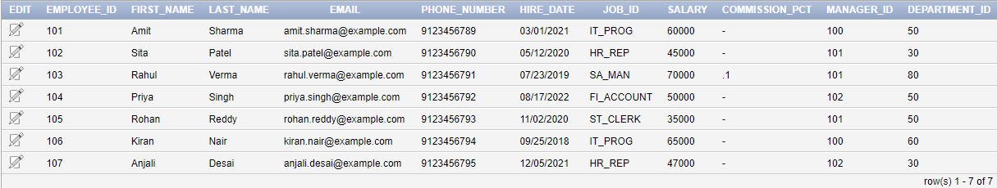

**Find the Solution for the following:**

1. Create a view called EMPLOYEE_VU based on the employee numbers, employee names

and department numbers from the EMPLOYEES table. Change the heading for the employee

name to EMPLOYEE.

**CREATE VIEW EMPLOYEE_VU AS**

**SELECT Employee_id,**

**First_Name || ' ' || Last_Name AS EMPLOYEE,**

**Department_id**

**FROM Employee;**

2. Display the contents of the EMPLOYEES_VU view.

**SELECT * FROM EMPLOYEE_VU;**

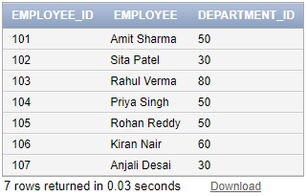

3. Select the view name and text from the USER_VIEWS data dictionary views.

**SELECT view_name, text**

**FROM user_views**

**WHERE view_name = 'EMPLOYEE_VU';**

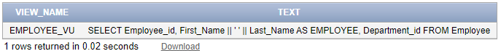

4. Using your EMPLOYEES_VU view, enter a query to display all employees names and

department.

**SELECT EMPLOYEE, Department_id**

**FROM EMPLOYEE_VU;**

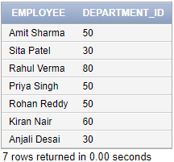

5. Create a view named DEPT50 that contains the employee number, employee last names

and department numbers for all employees in department 50.Label the view columns EMPNO,

EMPLOYEE and DEPTNO. Do not allow an employee to be reassigned to another department

through the view.

**CREATE VIEW DEPT50 AS**

**SELECT Employee_id AS EMPNO,**

**Last_Name AS EMPLOYEE,**

**Department_id AS DEPTNO**

**FROM Employee**

**WHERE Department_id = 50**

**WITH READ ONLY;**

6. Display the structure and contents of the DEPT50 view.

**DESC DEPT50;**

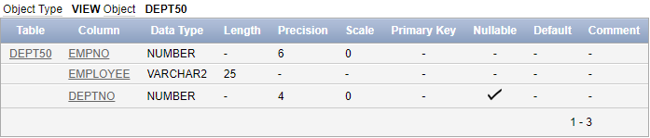

**SELECT * FROM DEPT50;**

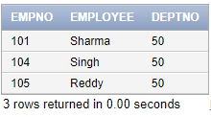

7. Attempt to reassign Matos to department 80.

**UPDATE DEPT50**

**SET DEPTNO = 80**

**WHERE EMPLOYEE = 'Matos';**

This should fail due to the READ ONLY constraint.

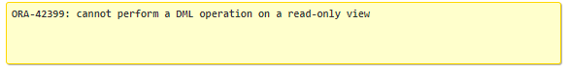

8. Create a view called SALARY_VU based on the employee last names, department

names, salaries, and salary grades for all employees. Use the Employees, DEPARTMENTS and

JOB_GRADE tables. Label the column Employee, Department, salary, and Grade respectively.

**CREATE VIEW SALARY_VU AS**

**SELECT**

**e.Last_Name AS Employee,**

**d.Dept_name AS Department,**

**e.Salary AS Salary,**

**jg.Grade_level AS Grade**

**FROM**

**Employee e**

**JOIN**

**Department d ON e.Department_id = d.Dept_id**

**JOIN**

**Job_Grade jg ON e.Salary BETWEEN jg.Lowest_sal AND jg.Highest_sal;**

**SELECT * FROM SALARY_VU;**

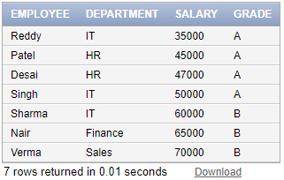

**RESULT:**

**Hence, views are created and executed successfully.**